**Period Four**

**学习目标：**

1.听懂、会说、正确读写单词：fisherman, scientist, pilot,coach.

2.能正确询问别人在什么地方上班并回答 “Where does he/she go to work? He/she goes to work by bike.”

一. Review to understand.(温故知新)

Read and choose.(读句子，选择相符的图片。)

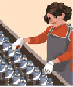 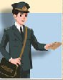  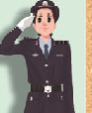

A B C D

1.He is a businessman. He is going to sell goods on the internet. ( )

2.My aunt is a police officer. ( )

3.My uncle is a post man. ( )

4.She is an factory worker. ( )

二.Warm-up（热身活动）

Choose the word to fill in the blanks.(选词填空。)

1. Where (do/does)you wok? I (works/work)at a primary school.
2. What (does/do)Tom do? Tom (are/is)a police officer.
3. He works (in/at)sea.

4.My uncle is a (fisherman/fishman).

三.Self check(自学检测)

1.Match the pictures with suitable words.(将图片与合适的单词连起来。)

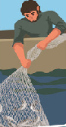  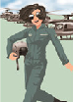 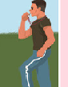

pilot coach fisherman scientist

1. Write and discuss on page 51.(课本第51页：写一写，议一议。）
2. Read the dialogue on page 46-47 and answer the questions.(读课本第46-47页对话，回答问题。）
3. .What does Oliver’s mother do?
4. What does Chen Jie want to be one day?
5. What does Amy’s father do?
6. Where does Amy’s father work?
7. What does Zhang Peng’s mother do? Where does she work?

四.Consolidation.（巩固练习）

Fill the blanks(用所给单词的适当形式填空)

1.He _____ (go) to work by bike.

2.How _______ (do) Chen Jie go to school?

3.Every day they ___ (read) books.

4.Tomorrow my parents are ___ (go) to the Great Wall.

5.Tim is a fisherman, and he (work)at sea.

五.Expanding Practice.(拓展训练)

Read the text and answer the questions.(读短文回答问题。)

Come and look at the photo of my family. This is my father. He is an engineer. He goes to work by car. My mother is an accountant. She goes to work by subway. The boy is me. I am a student. My home is next to the school. It’s not farm. So I go to school on foot.

1. How does the boy’s dad go to work ? ________________________________.

2. How does the boy go to school? ________________________________.

3. What does his mother do? ______________________________.

4. How many people in the family? _____________________________.

5. Is the boy a student? ________________________________.